|  |
| --- |
| **用户界面设计与分析**  **实验报告**  项目名称 SSD4实验二  专业班级 软件工程1803  学 号 8209180334  姓 名 刘文龙  **实验成绩：**  **批阅教师：**  2019年 11 月 20 日 |

**一、实验要求**

UAR组件在课程1.3.3如何编写可用性方面报告（UAR）中，您将了解UAR的主要组成部分。 对于本练习，您将创建一个应用程序，该应用程序将帮助您记住UAR的每个组件应包含的内容。您创建的应用程序应具有两个功能：

1）当用户通过编号选择UAR组件时，应用程序应显示该组件内容的描述； 2）当用户指定关键字或短语时，应用程序应在显示的描述中搜索该关键字或短语的出现次数，并以偏移量-数字的形式显示出现次数的计数以及第一次出现和最后一次出现的位置 从描述开始的字符集

遵循教科书（请参阅第747-50页）中的设计技巧和编程指南，您应创建包含以下元素的应用程序（请参见上面的示例界面）：

•七个标签控件列出了UAR组件；•一个文本框控件，用于显示所选UAR组件内容描述的文本作为输出。同样，遵循GUI设计和编程指南（Zak，第747-50页），将控件的ReadOnly属性设置为True，将TabStop属性设置为False，将MultiLine属性设置为True，将ScrollBars属性设置为Vertical；•描述输出文本框用途的标识标签控件（例如，上述示例界面中的“ UAR组件描述：”标签）；•两个文本框控件接受用户输入：一个文本框接受要显示的UAR组件内容描述的列表号（请注意，对于此文本框，有效输入将仅包含一个数字字符）；一个文本框接受要搜索的关键字（注意，搜索功能不应区分大小写）；•两个标识标签控件，每个控件描述输入文本框之一的用途；•两个命令按钮，一个用于启动显示功能，另一个用于启动搜索功能（请参见上面示例界面上的“显示”和“搜索”按钮），请确保为这些命令按钮提供访问键；•两个标签控件，用于显示关键字的第一个和最后一个位置（请注意，当不执行搜索（或未找到关键字）时，这些控件将不可见）；•标识标签用作显示关键字的第一个和最后一个位置的标签的标题（请参见上述界面上的“找到于：”标签）；•“退出”命令按钮。

**二、应用程序简介**

用Swing写出的纯前端界面，用于文本的获取和检索

**三、应用程序页面展示及说明**

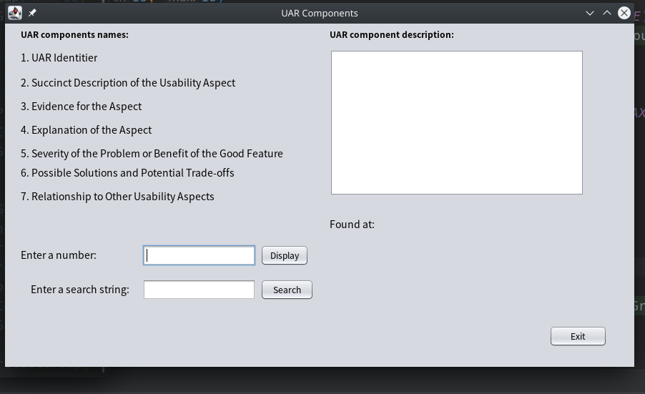

**操作一：当在Enter a number输入框中输入数字1~7，在右侧的框中可以显示出段落**

**输入数字“1”：**

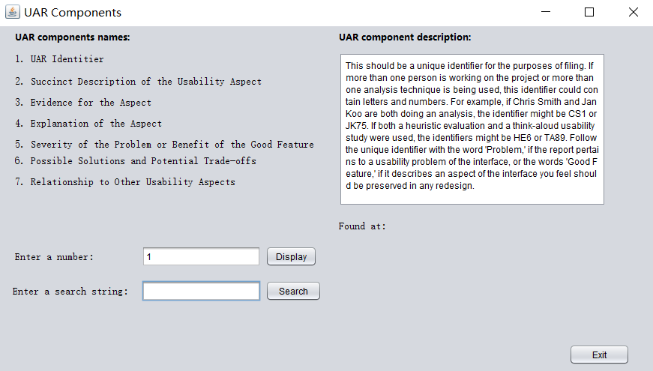

**输入数字“3”：**

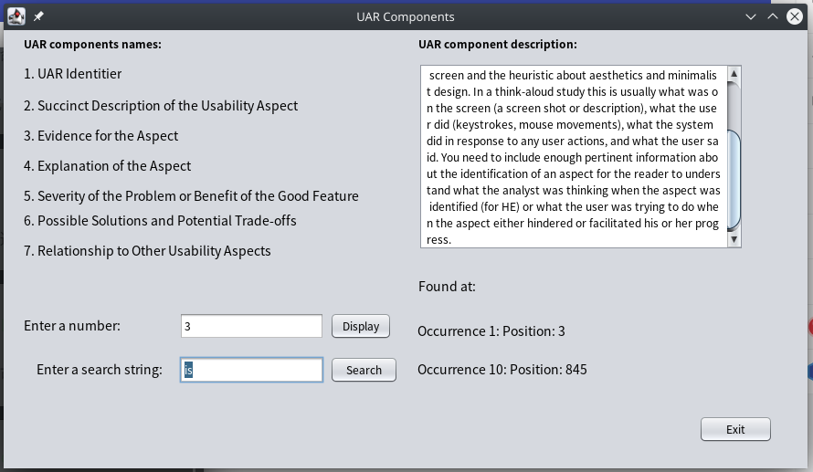

**操作二：在Enter a search string输入框中输入要查询某个单词的位置**

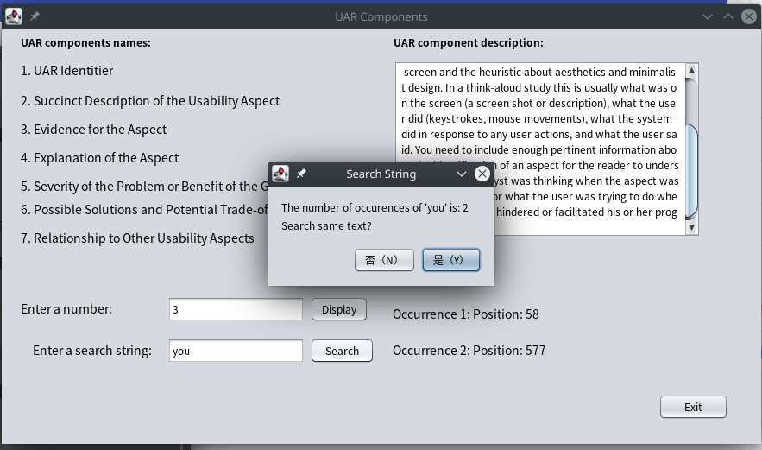

**输入字符串“you”**

**会弹出一个提示框，点击 “是（Y）”**

**如下图：**



**在右下角显示出具体位置**

**四、实验中遇到的问题**

1 主要使用javaswing进行程序开发。在开发过程中，主要时间消耗在前端的界面布局上，以及按键的事件绑定上。

2 在进行字符串检索那块，思索了好一会儿，最后参考网上的代码进行编写。

3 因为对javaswing的不熟悉，导致许多地方犯了一些无知的错误，不过熟能生巧，写了一会儿后找到了感觉

4 对于类的继承和函数的重写有点忘记了，在查阅相关资料后找到解决办法

**五、实验心得**

本次实验难度不大，不过却耗了一些时间，一方面固然是因为对语法方面的不熟悉，但是同样可以看出，自己仍有很大的不足，应该多加提升自己的水平。平时应该打好基础，不要太急，一步一步来。不能放弃对技术的学习，要亲自动手敲，要敲原创的代码。属于自己的代码，这样才能更好的提高自己的水平。

**六、附件：实验源代码**

import javax.swing.text.Document;

import javax.swing.JOptionPane;

import javax.swing.event.DocumentEvent;

import javax.swing.event.DocumentListener;

public class ssd4shiyan extends javax.swing.JFrame implements DocumentListener{

@Override

public void insertUpdate(DocumentEvent e) {

jTextArea1.setText("");

jTextField2.setText("");

jLabel13.setVisible(false);

jLabel14.setVisible(false);

}

@Override

public void removeUpdate(DocumentEvent e) {

jTextArea1.setText("");

jTextField2.setText("");

jLabel13.setVisible(false);

jLabel14.setVisible(false);

}

@Override

public void changedUpdate(DocumentEvent e) {

jTextArea1.setText("");

jTextField2.setText("");

jLabel13.setVisible(false);

jLabel14.setVisible(false);

}

public ssd4() {

initComponents();

this.setTitle("UAR Components");

this.jTextField1.requestFocus();

jLabel13.setVisible(false);

jLabel14.setVisible(false);

}

private void initComponents() {

jPanel1 = new javax.swing.JPanel();

jButton3 = new javax.swing.JButton();

jLabel14 = new javax.swing.JLabel();

jLabel13 = new javax.swing.JLabel();

jButton2 = new javax.swing.JButton();

jButton1 = new javax.swing.JButton();

jLabel10 = new javax.swing.JLabel();

jLabel11 = new javax.swing.JLabel();

jTextField1 = new javax.swing.JTextField();

jTextField2 = new javax.swing.JTextField();

jLabel12 = new javax.swing.JLabel();

jScrollPane1 = new javax.swing.JScrollPane();

jTextArea1 = new javax.swing.JTextArea();

jLabel7 = new javax.swing.JLabel();

jLabel6 = new javax.swing.JLabel();

jLabel5 = new javax.swing.JLabel();

jLabel4 = new javax.swing.JLabel();

jLabel3 = new javax.swing.JLabel();

jLabel2 = new javax.swing.JLabel();

jLabel1 = new javax.swing.JLabel();

jLabel8 = new javax.swing.JLabel();

jLabel9 = new javax.swing.JLabel();

setDefaultCloseOperation(javax.swing.WindowConstants.EXIT_ON_CLOSE);

setPreferredSize(new java.awt.Dimension(890, 510));

jPanel1.setPreferredSize(new java.awt.Dimension(705, 305));

jPanel1.setRequestFocusEnabled(false);

jButton3.setText("Exit");

jButton3.addMouseListener(new java.awt.event.MouseAdapter() {

public void mouseClicked(java.awt.event.MouseEvent evt) {

jButton3MouseClicked(evt);

}

});

jButton3.addActionListener(new java.awt.event.ActionListener() {

public void actionPerformed(java.awt.event.ActionEvent evt) {

jButton3ActionPerformed(evt);

}

});

jLabel14.setFont(new java.awt.Font("宋体", 0, 14)); // NOI18N

jLabel14.setText("jLabel14");

jLabel13.setFont(new java.awt.Font("宋体", 0, 14)); // NOI18N

jLabel13.setText("jLabel13");

jButton2.setText("Search");

jButton2.addMouseListener(new java.awt.event.MouseAdapter() {

public void mouseClicked(java.awt.event.MouseEvent evt) {

jButton2MouseClicked(evt);

}

});

jButton2.addActionListener(new java.awt.event.ActionListener() {

public void actionPerformed(java.awt.event.ActionEvent evt) {

jButton2ActionPerformed(evt);

}

});

jButton1.setText("Display");

jButton1.addMouseListener(new java.awt.event.MouseAdapter() {

public void mouseClicked(java.awt.event.MouseEvent evt) {

jButton1MouseClicked(evt);

}

});

jButton1.addActionListener(new java.awt.event.ActionListener() {

public void actionPerformed(java.awt.event.ActionEvent evt) {

jButton1ActionPerformed(evt);

}

});

jLabel10.setFont(new java.awt.Font("宋体", 0, 14)); // NOI18N

jLabel10.setText("Enter a number:");

jLabel11.setFont(new java.awt.Font("宋体", 0, 14)); // NOI18N

jLabel11.setText("Enter a search string:");

jTextField1.addActionListener(new java.awt.event.ActionListener() {

public void actionPerformed(java.awt.event.ActionEvent evt) {

jTextField1ActionPerformed(evt);

}

});

jTextField1.addPropertyChangeListener(new java.beans.PropertyChangeListener() {

public void propertyChange(java.beans.PropertyChangeEvent evt) {

jTextField1PropertyChange(evt);

}

});

jTextField2.addActionListener(new java.awt.event.ActionListener() {

public void actionPerformed(java.awt.event.ActionEvent evt) {

jTextField2ActionPerformed(evt);

}

});

jTextField2.addPropertyChangeListener(new java.beans.PropertyChangeListener() {

public void propertyChange(java.beans.PropertyChangeEvent evt) {

jTextField2PropertyChange(evt);

}

});

jLabel12.setFont(new java.awt.Font("宋体", 0, 14)); // NOI18N

jLabel12.setText("Found at:");

jTextArea1.setColumns(20);

jTextArea1.setLineWrap(true);

jTextArea1.setRows(5);

jScrollPane1.setViewportView(jTextArea1);

jLabel7.setFont(new java.awt.Font("宋体", 0, 14)); // NOI18N

jLabel7.setText("7. Relationship to Other Usability Aspects");

jLabel6.setFont(new java.awt.Font("宋体", 0, 14)); // NOI18N

jLabel6.setText("6. Possible Solutions and Potential Trade-offs");

jLabel5.setFont(new java.awt.Font("宋体", 0, 14)); // NOI18N

jLabel5.setText("5. Severity of the Problem or Benefit of the Good Feature");

jLabel4.setFont(new java.awt.Font("宋体", 0, 14)); // NOI18N

jLabel4.setText("4. Explanation of the Aspect");

jLabel3.setFont(new java.awt.Font("宋体", 0, 14)); // NOI18N

jLabel3.setText("3. Evidence for the Aspect");

jLabel2.setFont(new java.awt.Font("宋体", 0, 14)); // NOI18N

jLabel2.setText("2. Succinct Description of the Usability Aspect");

jLabel1.setFont(new java.awt.Font("宋体", 0, 14)); // NOI18N

jLabel1.setText("1. UAR Identitier");

jLabel8.setFont(new java.awt.Font("微软雅黑", 1, 12)); // NOI18N

jLabel8.setText("UAR components names:");

jLabel9.setFont(new java.awt.Font("微软雅黑", 1, 12)); // NOI18N

jLabel9.setText("UAR component description:");

javax.swing.GroupLayout jPanel1Layout = new javax.swing.GroupLayout(jPanel1);

jPanel1.setLayout(jPanel1Layout);

jPanel1Layout.setHorizontalGroup(

jPanel1Layout.createParallelGroup(javax.swing.GroupLayout.Alignment.LEADING)

.addGroup(jPanel1Layout.createSequentialGroup()

.addGroup(jPanel1Layout.createParallelGroup(javax.swing.GroupLayout.Alignment.LEADING)

.addGroup(jPanel1Layout.createSequentialGroup()

.addGap(22, 22, 22)

.addGroup(jPanel1Layout.createParallelGroup(javax.swing.GroupLayout.Alignment.LEADING)

.addComponent(jLabel1)

.addComponent(jLabel8)

.addComponent(jLabel2)

.addComponent(jLabel3)

.addComponent(jLabel4)

.addComponent(jLabel6)

.addComponent(jLabel7)

.addComponent(jLabel5, javax.swing.GroupLayout.PREFERRED_SIZE, 413, javax.swing.GroupLayout.PREFERRED_SIZE)))

.addGroup(jPanel1Layout.createSequentialGroup()

.addGroup(jPanel1Layout.createParallelGroup(javax.swing.GroupLayout.Alignment.LEADING)

.addGroup(jPanel1Layout.createSequentialGroup()

.addGap(22, 22, 22)

.addComponent(jLabel10)

.addGap(64, 64, 64))

.addGroup(javax.swing.GroupLayout.Alignment.TRAILING, jPanel1Layout.createSequentialGroup()

.addContainerGap()

.addComponent(jLabel11)

.addGap(18, 18, 18)))

.addGroup(jPanel1Layout.createParallelGroup(javax.swing.GroupLayout.Alignment.TRAILING)

.addComponent(jTextField1, javax.swing.GroupLayout.Alignment.LEADING, javax.swing.GroupLayout.PREFERRED_SIZE, 159, javax.swing.GroupLayout.PREFERRED_SIZE)

.addComponent(jTextField2, javax.swing.GroupLayout.Alignment.LEADING, javax.swing.GroupLayout.PREFERRED_SIZE, 159, javax.swing.GroupLayout.PREFERRED_SIZE))

.addPreferredGap(javax.swing.LayoutStyle.ComponentPlacement.RELATED)

.addGroup(jPanel1Layout.createParallelGroup(javax.swing.GroupLayout.Alignment.LEADING)

.addComponent(jButton2, javax.swing.GroupLayout.PREFERRED_SIZE, 75, javax.swing.GroupLayout.PREFERRED_SIZE)

.addComponent(jButton1))))

.addGroup(jPanel1Layout.createParallelGroup(javax.swing.GroupLayout.Alignment.LEADING)

.addGroup(jPanel1Layout.createSequentialGroup()

.addGap(18, 18, 18)

.addComponent(jLabel14))

.addGroup(jPanel1Layout.createSequentialGroup()

.addGap(18, 18, 18)

.addComponent(jLabel13))

.addGroup(jPanel1Layout.createSequentialGroup()

.addGap(19, 19, 19)

.addGroup(jPanel1Layout.createParallelGroup(javax.swing.GroupLayout.Alignment.LEADING)

.addComponent(jLabel9)

.addComponent(jScrollPane1, javax.swing.GroupLayout.PREFERRED_SIZE, 356, javax.swing.GroupLayout.PREFERRED_SIZE)

.addComponent(jLabel12))))

.addContainerGap(70, Short.MAX_VALUE))

.addGroup(javax.swing.GroupLayout.Alignment.TRAILING, jPanel1Layout.createSequentialGroup()

.addGap(0, 0, Short.MAX_VALUE)

.addComponent(jButton3, javax.swing.GroupLayout.PREFERRED_SIZE, 81, javax.swing.GroupLayout.PREFERRED_SIZE)

.addGap(38, 38, 38))

);

jPanel1Layout.setVerticalGroup(

jPanel1Layout.createParallelGroup(javax.swing.GroupLayout.Alignment.LEADING)

.addGroup(jPanel1Layout.createSequentialGroup()

.addContainerGap()

.addGroup(jPanel1Layout.createParallelGroup(javax.swing.GroupLayout.Alignment.BASELINE)

.addComponent(jLabel9)

.addComponent(jLabel8))

.addPreferredGap(javax.swing.LayoutStyle.ComponentPlacement.UNRELATED)

.addGroup(jPanel1Layout.createParallelGroup(javax.swing.GroupLayout.Alignment.LEADING)

.addComponent(jScrollPane1, javax.swing.GroupLayout.PREFERRED_SIZE, 205, javax.swing.GroupLayout.PREFERRED_SIZE)

.addGroup(jPanel1Layout.createSequentialGroup()

.addComponent(jLabel1)

.addGap(14, 14, 14)

.addComponent(jLabel2)

.addPreferredGap(javax.swing.LayoutStyle.ComponentPlacement.UNRELATED)

.addComponent(jLabel3)

.addPreferredGap(javax.swing.LayoutStyle.ComponentPlacement.UNRELATED)

.addComponent(jLabel4)

.addPreferredGap(javax.swing.LayoutStyle.ComponentPlacement.UNRELATED)

.addComponent(jLabel5)

.addPreferredGap(javax.swing.LayoutStyle.ComponentPlacement.RELATED)

.addComponent(jLabel6)

.addPreferredGap(javax.swing.LayoutStyle.ComponentPlacement.UNRELATED)

.addComponent(jLabel7)))

.addGap(18, 18, 18)

.addComponent(jLabel12)

.addGroup(jPanel1Layout.createParallelGroup(javax.swing.GroupLayout.Alignment.LEADING)

.addGroup(jPanel1Layout.createSequentialGroup()

.addGap(19, 19, 19)

.addGroup(jPanel1Layout.createParallelGroup(javax.swing.GroupLayout.Alignment.BASELINE)

.addComponent(jTextField1, javax.swing.GroupLayout.PREFERRED_SIZE, javax.swing.GroupLayout.DEFAULT_SIZE, javax.swing.GroupLayout.PREFERRED_SIZE)

.addComponent(jButton1)

.addComponent(jLabel10)))

.addGroup(javax.swing.GroupLayout.Alignment.TRAILING, jPanel1Layout.createSequentialGroup()

.addPreferredGap(javax.swing.LayoutStyle.ComponentPlacement.RELATED)

.addComponent(jLabel13)))

.addGap(18, 18, 18)

.addGroup(jPanel1Layout.createParallelGroup(javax.swing.GroupLayout.Alignment.BASELINE)

.addComponent(jTextField2, javax.swing.GroupLayout.PREFERRED_SIZE, javax.swing.GroupLayout.DEFAULT_SIZE, javax.swing.GroupLayout.PREFERRED_SIZE)

.addComponent(jLabel11)

.addComponent(jButton2)

.addComponent(jLabel14))

.addPreferredGap(javax.swing.LayoutStyle.ComponentPlacement.RELATED, 70, Short.MAX_VALUE)

.addComponent(jButton3)

.addGap(138, 138, 138))

);

javax.swing.GroupLayout layout = new javax.swing.GroupLayout(getContentPane());

getContentPane().setLayout(layout);

layout.setHorizontalGroup(

layout.createParallelGroup(javax.swing.GroupLayout.Alignment.LEADING)

.addGroup(layout.createSequentialGroup()

.addComponent(jPanel1, javax.swing.GroupLayout.PREFERRED_SIZE, 880, javax.swing.GroupLayout.PREFERRED_SIZE)

.addGap(0, 0, Short.MAX_VALUE))

);

layout.setVerticalGroup(

layout.createParallelGroup(javax.swing.GroupLayout.Alignment.LEADING)

.addGroup(layout.createSequentialGroup()

.addComponent(jPanel1, javax.swing.GroupLayout.PREFERRED_SIZE, 590, javax.swing.GroupLayout.PREFERRED_SIZE)

.addContainerGap())

);

pack();

}

private void jTextField1ActionPerformed(java.awt.event.ActionEvent evt) {

// TODO add your handling code here:

}

private void jButton1ActionPerformed(java.awt.event.ActionEvent evt) {

// TODO add your handling code here:

}

private void jButton3ActionPerformed(java.awt.event.ActionEvent evt) {

// TODO add your handling code here:

}

private void jButton1MouseClicked(java.awt.event.MouseEvent evt) {

// TODO add your handling code here:

try{

Integer.parseInt(jTextField1.getText());

}catch(Exception e){

// 不是int

JOptionPane.showMessageDialog(null, "Please enter value between 1 and 7", "Search String", JOptionPane.WARNING_MESSAGE);

jTextField1.requestFocus();

jTextField1.selectAll();

}

int number = Integer.parseInt(jTextField1.getText());

switch(number){

case 1 : {

jTextArea1.setText("This should be a unique identifier for the purposes of filing. If more than one person is working on the project or more than one analysis technique is being used, this identifier could contain letters and numbers. For example, if Chris Smith and Jan Koo are both doing an analysis, the identifier might be CS1 or JK75. If both a heuristic evaluation and a think-aloud usability study were used, the identifiers might be HE6 or TA89. Follow the unique identifier with the word 'Problem,' if the report pertains to a usability problem of the interface, or the words 'Good Feature,' if it describes an aspect of the interface you feel should be preserved in any redesign.");

jTextField2.requestFocus();

break;

}

case 2 :{

jTextArea1.setText("This description will be used as the 'name' of this UAR when you talk about its relation to other UARs. Make the name as short as possible (about three to five words) but still descriptive and distinguishable from other aspects of the system. If this UAR is about a problem (as opposed to a good feature), make sure you have a name that describes the problem, rather than a solution.");

jTextField2.requestFocus();

break;

}

case 3 :{

jTextArea1.setText("This is the objective supporting material that justifies your identifying the aspect as worthy of report. This section needs to contain enough information for a reader of this UAR to understand what triggered the report. For an HE report, for instance, this could be an image of a cluttered screen and the heuristic about aesthetics and minimalist design. In a think-aloud study this is usually what was on the screen (a screen shot or description), what the user did (keystrokes, mouse movements), what the system did in response to any user actions, and what the user said. You need to include enough pertinent information about the identification of an aspect for the reader to understand what the analyst was thinking when the aspect was identified (for HE) or what the user was trying to do when the aspect either hindered or facilitated his or her progress.");

jTextField2.requestFocus();

break;

}

case 4 :{

jTextArea1.setText("This is your interpretation of the evidence. That is, for a think-aloud usability test, why you think what happened happened, or, for an HE, why you think the aspect was designed the way it was. You need to provide enough content in this explanation for the reader to understand the problem-even if they do not know the system or domain as well as you do.");

jTextField2.requestFocus();

break;

}

case 5 :{

jTextArea1.setText("This is your reasoning about how important it is to either fix this problem or preserve this good feature. This includes how frequently the users will experience this aspect, whether they are likely to learn how it works, whether it will affect new users, casual users, experienced users, etc.");

jTextField2.requestFocus();

break;

}

case 6 :{

jTextArea1.setText("If this aspect is a problem (as opposed to a good feature to be preserved in the next version of the software), this is the place to propose a solution. It is not necessary to have a solution as soon as you identify a problem-you might find after analyzing the whole interface that many problems are related and can all be fixed by making a single broad change instead of making several small changes. However, if you do propose a possible solution, report any potential design trade-offs that you see");

jTextField2.requestFocus();

break;

}

case 7 :{

jTextArea1.setText("It is often the case that UARs are related to each other. This is where you record which UARs this one is related to and a statement about how it is related. Make sure that all the related UARs point to each other. It is a common mistake to enter the pointer into a newly created UAR, but neglect to go back to the previous ones that it relates to and update their UARs.");

jTextField2.requestFocus();

break;

}

default:{

JOptionPane.showMessageDialog(null, "Please enter value between 1 and 7", "Search String", JOptionPane.WARNING_MESSAGE);

jTextField1.requestFocus();

jTextField1.selectAll();

break;

}

}

}

private void jButton3MouseClicked(java.awt.event.MouseEvent evt) {

// TODO add your handling code here:

System.exit(WIDTH);

}

private void jButton2ActionPerformed(java.awt.event.ActionEvent evt) {

// TODO add your handling code here:

}

private void jButton2MouseClicked(java.awt.event.MouseEvent evt) {

// TODO add your handling code here:

if(jTextArea1.getText().length() == 0 || jTextField1.getText().length() == 0){

JOptionPane.showMessageDialog(null, "Please select text", "Search String", JOptionPane.WARNING_MESSAGE);

jButton1.requestFocus();

}

else if(jTextField2.getText().length() == 0){

JOptionPane.showMessageDialog(null, "Please enter a search String", "Search String", JOptionPane.WARNING_MESSAGE);

jTextField2.requestFocus();

jLabel13.setVisible(false);

jLabel14.setVisible(false);

}

else{

String _sourse = jTextArea1.getText().toLowerCase();

String _search = jTextField2.getText().toLowerCase();

int total = 0;

int first,last;

first = 0;

last = 0;

int countLoop = 0;

for(String temp = _sourse; temp != null && temp.length() >= _search.length(); ){

if(temp.indexOf(_search) == 0){

countLoop += _search.length();

total++;

if(total == 1){

first = countLoop - _search.length() + 1;

}

last = countLoop - _search.length() + 1;

temp = _sourse.substring(countLoop);

}

else{

countLoop += 1;

temp = _sourse.substring(countLoop);

}

}

Object[] options = {"是（Y）","否（N）"};

if(total == 0){

int response = JOptionPane.showOptionDialog(this, "String '"+ _search + "' not found " +total+ "\nSearch same text again?",

"Search String", JOptionPane.YES_OPTION, JOptionPane.WARNING_MESSAGE, null, options, options[0]);

if(response == 0){

jTextField2.requestFocus();

jTextField2.selectAll();

jLabel13.setVisible(false);

jLabel14.setVisible(false);

}

if(response == 1){

jTextField1.setText("");

jTextField2.setText("");

jTextArea1.setText("");

jLabel13.setVisible(false);

jLabel14.setVisible(false);

jTextField1.requestFocus();

}

}

else{

int response = JOptionPane.showOptionDialog(this, "The number of occurences of '"+ _search + "' is: " +total+ "\nSearch same text?",

"Search String", JOptionPane.YES_OPTION, JOptionPane.PLAIN_MESSAGE, null, options, options[0]);

if(response == 0){

jTextField2.requestFocus();

jTextField2.selectAll();

if(total == 1){

jLabel13.setVisible(true);

jLabel13.setText("Occurrence 1: Position: " + first);

}

else{

jLabel13.setVisible(true);

jLabel14.setVisible(true);

jLabel13.setText("Occurrence 1: Position: " + first);

jLabel14.setText("Occurrence " + total + ": Position: " + last);

}

}

if(response == 1){

jTextField1.setText("");

jTextField2.setText("");

jTextArea1.setText("");

jLabel13.setVisible(false);

jLabel14.setVisible(false);

jTextField1.requestFocus();

}

}

}

}

private void jTextField1PropertyChange(java.beans.PropertyChangeEvent evt) {

// TODO add your handling code here:

Document doc = jTextField1.getDocument();

//添加DocumentListener监听器

doc.addDocumentListener(this);

}

private void jTextField2ActionPerformed(java.awt.event.ActionEvent evt) {

// TODO add your handling code here:

jTextField2.setText(null);

}

private void jTextField2PropertyChange(java.beans.PropertyChangeEvent evt) {

// TODO add your handling code here:

if(jTextField2.isValid()){

jLabel13.setVisible(false);

jLabel14.setVisible(false);

}

}

public static void main(String args[]) {

/* Set the Nimbus look and feel */

//<editor-fold defaultstate="collapsed" desc=" Look and feel setting code (optional) ">

/* If Nimbus (introduced in Java SE 6) is not available, stay with the default look and feel.

* For details see http://download.oracle.com/javase/tutorial/uiswing/lookandfeel/plaf.html

*/

try {

for (javax.swing.UIManager.LookAndFeelInfo info : javax.swing.UIManager.getInstalledLookAndFeels()) {

if ("Nimbus".equals(info.getName())) {

javax.swing.UIManager.setLookAndFeel(info.getClassName());

break;

}

}

} catch (ClassNotFoundException ex) {

java.util.logging.Logger.getLogger(ssd4.class.getName()).log(java.util.logging.Level.SEVERE, null, ex);

} catch (InstantiationException ex) {

java.util.logging.Logger.getLogger(ssd4.class.getName()).log(java.util.logging.Level.SEVERE, null, ex);

} catch (IllegalAccessException ex) {

java.util.logging.Logger.getLogger(ssd4.class.getName()).log(java.util.logging.Level.SEVERE, null, ex);

} catch (javax.swing.UnsupportedLookAndFeelException ex) {

java.util.logging.Logger.getLogger(ssd4.class.getName()).log(java.util.logging.Level.SEVERE, null, ex);

}

//</editor-fold>

//</editor-fold>

//</editor-fold>

//</editor-fold>

/* Create and display the form */

java.awt.EventQueue.invokeLater(new Runnable() {

public void run() {

new ssd4().setVisible(true);

}

});

}

// Variables declaration - do not modify

private javax.swing.JButton jButton1;

private javax.swing.JButton jButton2;

private javax.swing.JButton jButton3;

private javax.swing.JLabel jLabel1;

private javax.swing.JLabel jLabel10;

private javax.swing.JLabel jLabel11;

private javax.swing.JLabel jLabel12;

private javax.swing.JLabel jLabel13;

private javax.swing.JLabel jLabel14;

private javax.swing.JLabel jLabel2;

private javax.swing.JLabel jLabel3;

private javax.swing.JLabel jLabel4;

private javax.swing.JLabel jLabel5;

private javax.swing.JLabel jLabel6;

private javax.swing.JLabel jLabel7;

private javax.swing.JLabel jLabel8;

private javax.swing.JLabel jLabel9;

private javax.swing.JPanel jPanel1;

private javax.swing.JScrollPane jScrollPane1;

private javax.swing.JTextArea jTextArea1;

private javax.swing.JTextField jTextField1;

private javax.swing.JTextField jTextField2;

// End of variables declaration

}